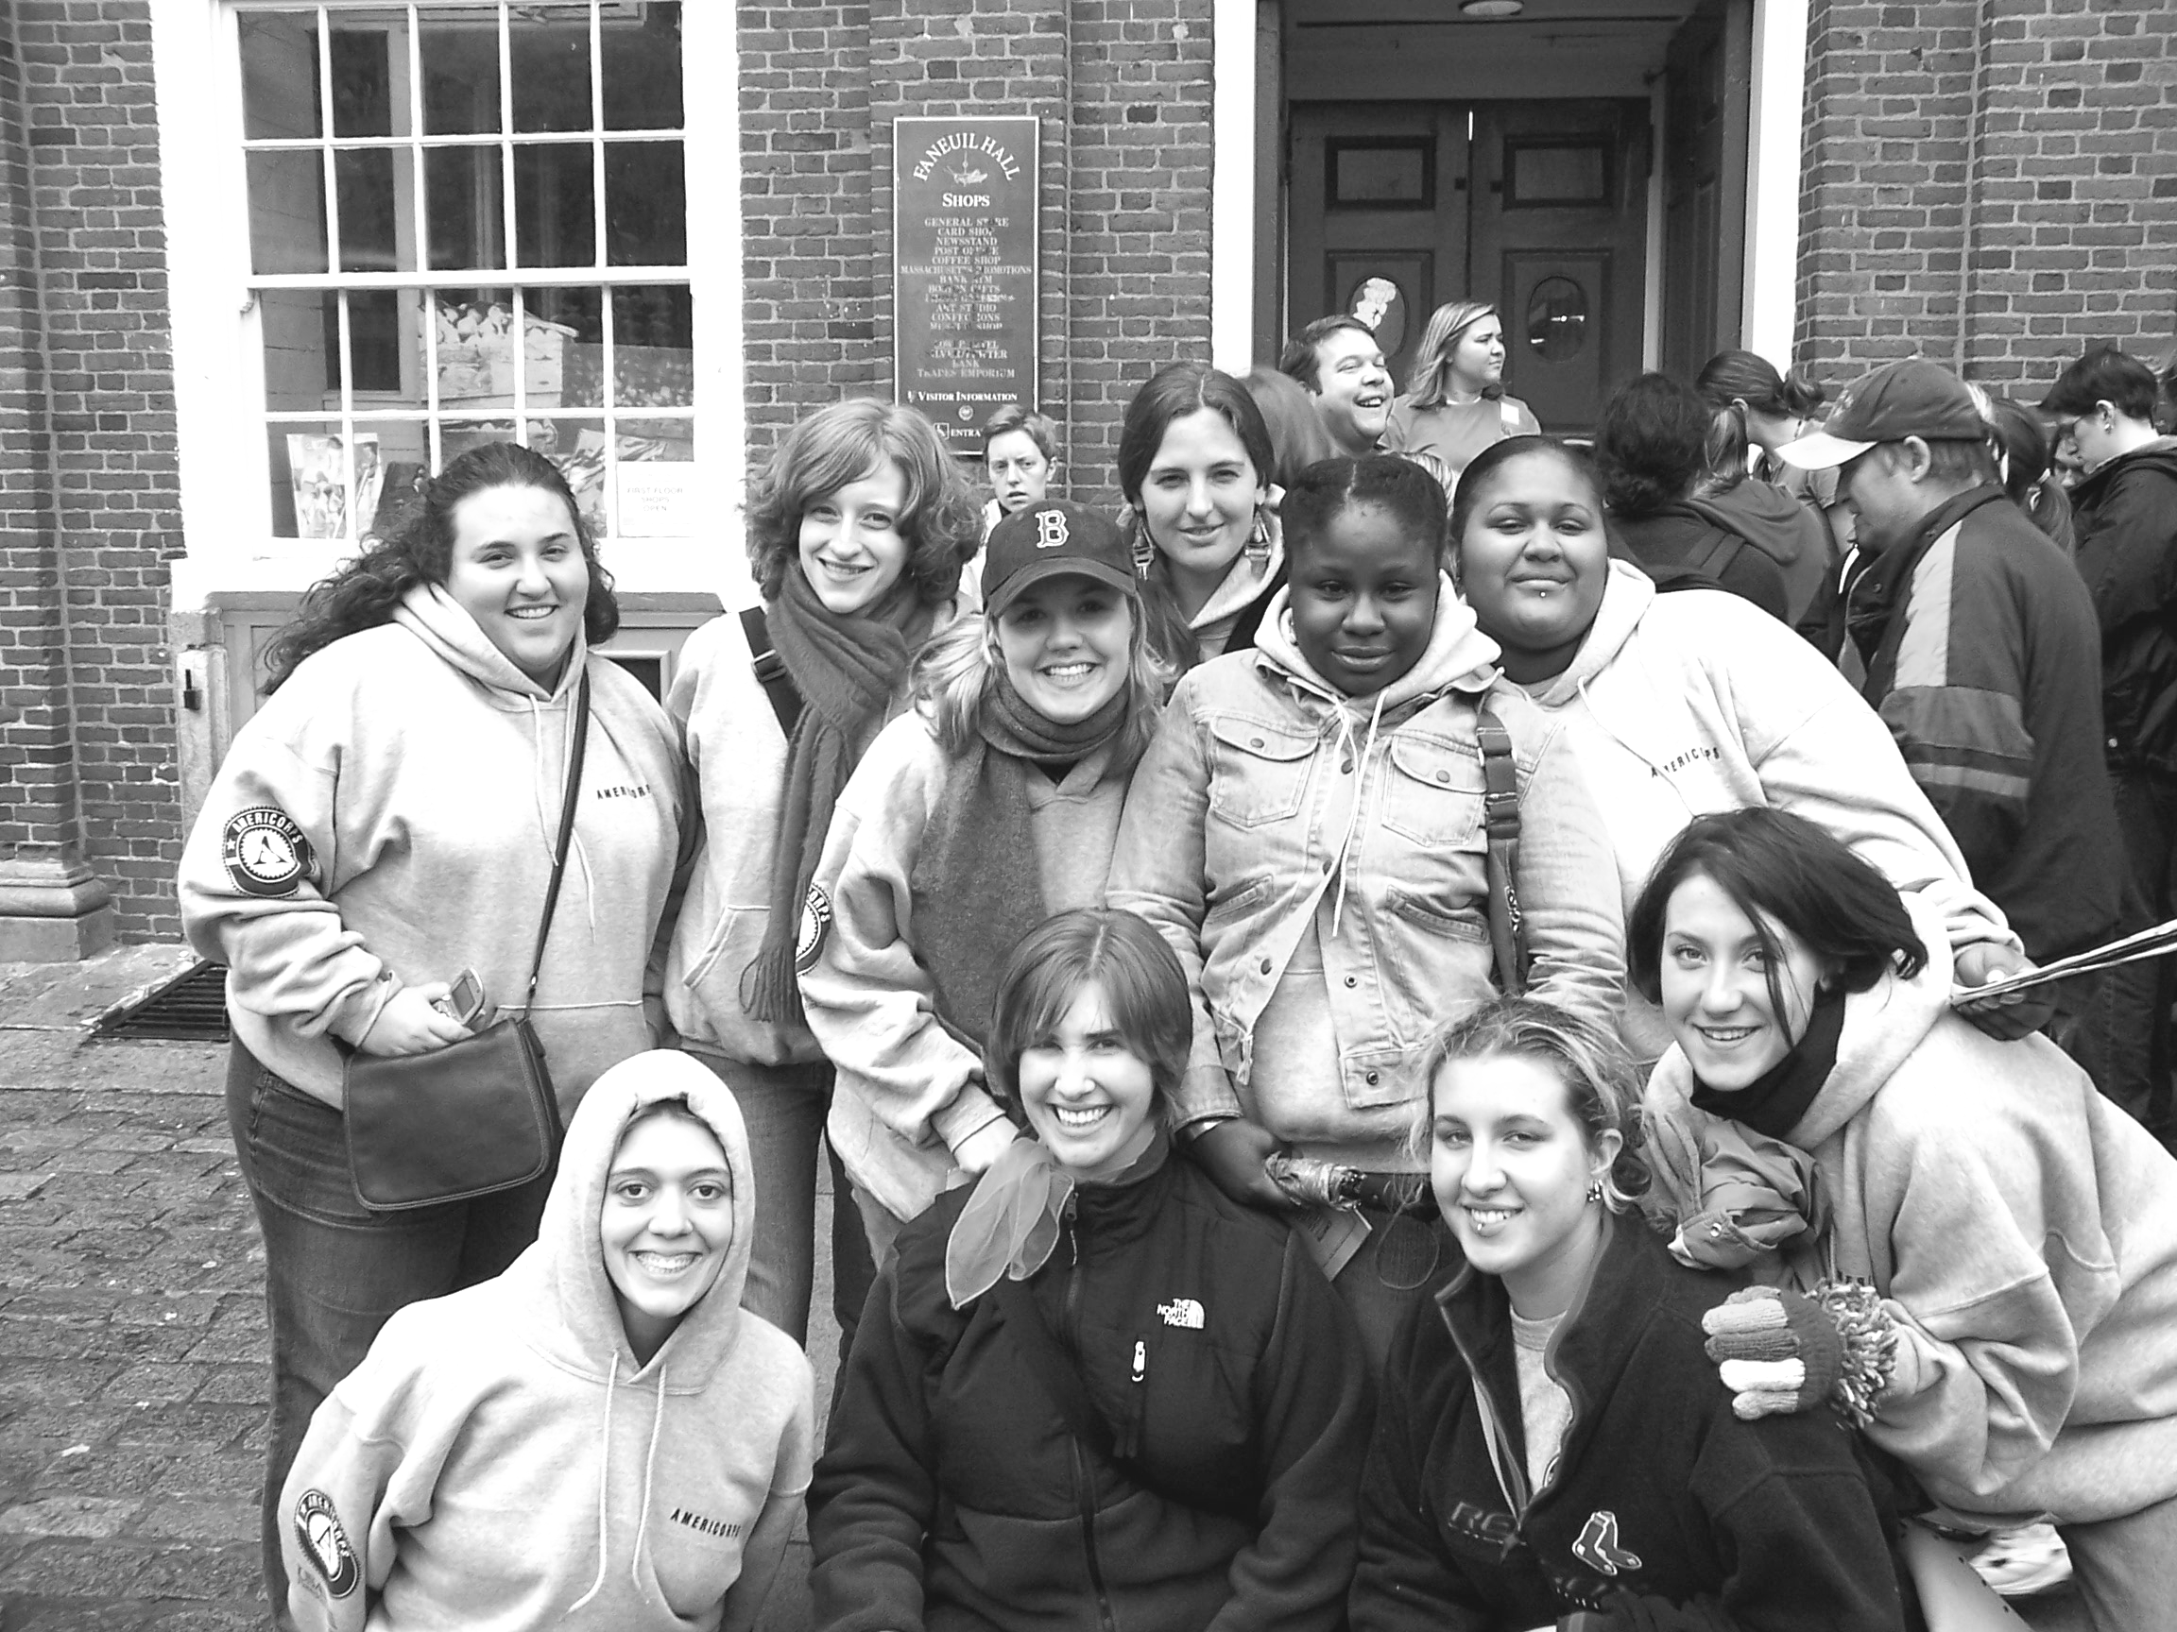

YouthServe AmeriCorps Program
Member Handbook
2008-2009
Note: This document is now available online. Please don’t waste paper by printing it out!
If you need a copy, contact the Program Director.
She will furnish you with a double-sided copy.
The trees thank you.
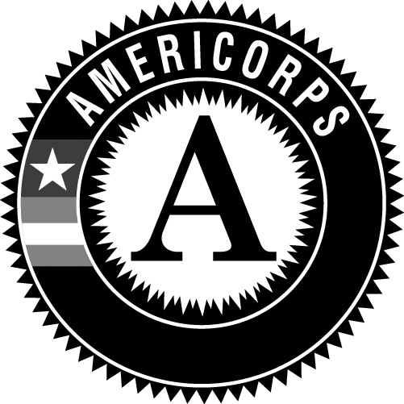


This document is now available online at www.dialself.org/americorps/download.htm

Table of Contents

General Information
Introduction to AmeriCorps 3
DIAL/SELF Mission 4
YouthServe Overview 4
YouthServe Mission and Objectives 5
YouthServe Site Partners 6

Member Benefits
Stipend/Living Allowance 7
Health Insurance 7
Child Care 8
Education Award 8
Loan Forbearance 9
Training 9
Member “Personal” Time and Jury Duty 10
AmeriCorps Gear 11

YouthServe Policies and Member Expectations
YouthServe Policies—General Statement 12
Confidentiality 12
Fraternization 12
Mandated Reporting 13
Prohibited Member Activities 13
Clarification on Fundraising as a Prohibited Activity 14

Hours
Member Term of Service 15
Hours Requirements 16
Direct Service 16
Training and Education 16
Reflection 16
Other Hours 16
Reading 17
Travel 17
Timesheet Signatures 17
Holidays 18

Evaluation and Tracking
YouthServe Paperwork 18
Member Evaluations 18
Program Evaluations 19

Introduction to AmeriCorps

AmeriCorps supports local, state and national organizations across the nation that involve Americans of all ages in results-driven community service. Created in 1993, the Corporation for National and Community Service engages more than 1.5 million Americans annually in improving communities through service. In 2004-2005, more than 50,000 Americans served as AmeriCorps members in more than 900 programs nationwide. AmeriCorps members are united by four common goals:

- Expanding Opportunity by enhancing members’ educational opportunities, job experience, and life skills;

- Encouraging Responsibility by enabling members to explore and exercise their responsibilities toward their communities, their families, and themselves;

- Strengthening Communities by bringing together Americans of all ages and backgrounds in the common effort to improve our communities; and

- Getting Things Done through direct and demonstrable service that helps solve community problems in the areas of education, public safety, environment and other human needs.

AMERICORPS NATIONAL SERVICE NETWORK
AmeriCorps*NCCC

(National Civilian
Community Corps)
AmeriCorps*State and National

(e.g., YouthServe
AmeriCorps Program)
AmeriCorps*VISTA

(Volunteers in Service
to America)

DIAL/SELF Mission

To empower children, youth and young adults by creating and expanding positive opportunities and support in their communities



Helping Youth Help Themselves Since 1977

Goals

- To provide housing and life skill programs that assist youth in making successful transitions to independent living

- To provide outreach services that expand youth’s ability to identify and access needed community resources

- To provide prevention programs and services aimed at reducing and preventing at-risk behavior

- To provide community service options for youth that expands their ability to connect and commit to their communities

YouthServe Overview

The YouthServe AmeriCorps Program is designed to assist the Franklin and Hampshire County and North Quabbin communities in their efforts to help teens from at-risk backgrounds avoid violent and destructive behaviors by leading recreational programs, offering educational and life skills support and providing access to local resources.

YouthServe members are dedicated to providing opportunities for the region’s at-risk youth to interact with caring adults and participate in safe and consistent prevention and enrichment programs to help influence participants attitudes towards risky behaviors. To achieve its goals, YouthServe employs a collaborative, multi-site model in which each member serves at a partnering youth agency. At these sites, members plan and lead recreational activities, offer educational and life skills support and provide transportation to help youth access community resources. Members also develop mentoring relationships with youth and provide settings in which youth can feel good about themselves, avoid destructive behaviors and reach their own goals. In addition, the program’s members build collaborations and foster connection among community members.

Each of YouthServe’s partnering sites offers a unique experience for members to develop professional skills and get experience working directly with at-risk youth. Each site offers members flexibility to pursue personal interests and training to develop specific skills. In her or his own way, each member brings something unique to the local children, youth and young adults, thereby leaving a personal mark on the community.

In addition to providing over 20,000 hours of direct service to youth, YouthServe members work as a team to plan and implement community projects throughout the year. YouthServe’s projects are designed to promote community collaboration and engage young people in community service.

YouthServe Mission and Objectives

YouthServe is designed to assist the Franklin and Hampshire County and North Quabbin communities in their efforts to help youth from at-risk backgrounds avoid violent and destructive behaviors by leading recreational programs, offering educational and life skills support and providing access to local resources. Formally, for grant-maintenance purposes, our stated objectives are:

Positive Youth Development

- Members will provide local youth ages 11-22 with opportunities for personal growth and development through recreation, prevention, and education programming.
- Members will elevate the protective factor of recognition for area youth by implementing recognition strategies in schools, after-school groups, and in the community.

Member Development

- Civic engagement trainings will equip members with the knowledge and skills necessary to participate in civic life.

Community Strengthening

- Members will recruit community volunteers to help support local youth agencies and programs.

YouthServe Site Partners

The YouthServe AmeriCorps Program has relationships with several youth-serving agencies in the area. YouthServe places members with these Site Partners to help the local community meet the needs of its youth.

The following organizations are the 2008-2009 YouthServe site partners:

- Big Brothers/Big Sisters of Franklin County
- The Brick House
- DIAL/SELF Youth and Community Services
- Community Action! Youth Programs
- Greenfield School Department
- Big Brothers/Big Sisters of Hampshire County
- Northfield Mount Hermon Upward Bound
- Athol School Department
- Gill-Montague School Department
- Youth Action Coalition
- Smith Vocational and Agricultural High School
- ServiceNet Inc.

For contact information at any of these agencies, please refer to the YouthServe Site Partner Contact Information Sheet at www.dialself.org/americorps/download

Stipend/Living Allowance

Full-time members will receive a living allowance of $11,400.

The living allowance will be distributed by check semi-monthly in accordance with DIAL/SELF’s policies on check distribution. Checks are generally distributed on alternate Fridays. For a ten-month term of service, members will receive 22 equal payments unless another schedule is mutually decided between YouthServe and the member.

A member may decide to waive her/his right to receive the living allowance. The member may, however, revoke such waiver at any time during the course of the program. If the member revokes the wavier, she/he may begin receiving the living allowance only from the date on which the waiver was revoked. She/he may not receive any portion of the living allowance that has accrued during the waiver period.

Health Insurance

Full-time members are entitled to receive health insurance provided by YouthServe. This insurance requires no contribution from AmeriCorps members. It will be effective from the member’s date of enrollment through the date of exit, but not past July 31, except during any period when the member is removed from active status. Members who extend their term of service into August and wish to continue health insurance coverage through YouthServe will be responsible for the cost of the insurance for the month of August.

More detailed insurance information is provided separately, but at a minimum, the policy covers:

- Services for illness or injury provided by a physician, surgeon, registered nurse, professional anesthetist or radiologist;
- Hospital charges;
- Emergency room care;
- X-ray, laboratory and diagnostic examinations;
- Prescription drugs;
- Limited mental or nervous condition disorders; and
- Limited substance abuse.

Members who are covered by another health care plan are not eligible for participation in the plan offered by YouthServe. Members, in such cases, may waive health insurance coverage. Such a waiver may be revoked should the member lose coverage during the term of service.

The plan offered by YouthServe provides coverage for the member only. Dependants are not covered under the plan.

Child Care

The Corporation for National Service offers child care benefits to all full-time AmeriCorps members who are income eligible, whose children are young than thirteen (13) years of age, and who need child care to be paid for in order to participate in AmeriCorps. Members may use these benefits to pay for a variety of types of childcare.

To receive AmeriCorps childcare benefits, the member must satisfy all of the following requirements:

- Serve as a full-time member performing 1700 hours of service in a 12-month period;
- Be the parent or documented legal guardian of a child who is under 13 years of age, who resides with the member;
- Need childcare to be paid for in order to participate in AmeriCorps; and
- Have a family income that meets guidelines set by the Massachusetts Child Care and Development Fund.

To receive the benefit, the member and the YouthServe Director must complete and submit the appropriate paperwork, which is provided separately.

Education Award

To qualify for the education award, AmeriCorps members must successfully complete the term of service for which they enrolled. Upon completion, Full-time members are eligible for an award of $4,725; Part-time members are eligible for an award of $2,362.50. The education award may be used in any or all of the following ways:
- to repay qualified existing or future student loans;
- to pay all or part of the current cost of attending a qualified institution of higher learning (including certain vocational programs); or
- to pay current expenses while participating in an approved school-to-work program.

Most postsecondary loans that are backed by the federal government are qualified for repayment with an AmeriCorps education award. Qualified loans include:

- Stafford Loans
- William D. Ford Direct Loans
- Supplemental Loans for Students
- Nursing Student Loans Assistance Loans
- Perkins Loans
- Federal Consolidated Loans
- Primary Care Loans
- Health Education

Your education award is managed by the National Service Trust. It is important to keep the National Service Trust informed of any address changes and to contact the Trust directly with any post-service concerns regarding the education award.

Contact the National Service Trust at (888) 507-5962 or www.americorps.org.

You can use your education award at most institutions of higher education (including graduate and professional programs), as well as some vocational schools. An institution is considered qualified for the education award if it has an agreement with the U.S. Department of Education whereby its students are eligible for at least one of the federally backed forms of financial assistance—such as Pell Grants, Perkins Loans, Stafford Loans, National Direct Loans, and Federal Consolidated Loans. To make sure the institution you want to attend is qualified, check with the financial aid office to see that they are a Title IV school before you make specific plans.

The education award is available any time after you receive a voucher from the National Service Trust for seven years after the date your service ended. You can apply for an extension beyond the seven years if:
- You are unavoidably prevented from using the award during that time; or
- You perform another term of service in an approved program.
To be considered for an extension, you must apply before the end of the seven-year period.

The education award will be taxed in the year that it is used.

Loan Forbearance

AmeriCorps members may request forbearance on qualified student loans during their AmeriCorps term of service. Forbearance is not automatic; you must request it. During a period of forbearance, you do not have to make payments, although interest continues to accumulate on your loans. Upon successful completion of the term of service, AmeriCorps will pay the interest that accrued.

Interest paid by AmeriCorps counts as taxable income in the year it is paid.

To have AmeriCorps pay that interest, members must complete and submit an Interest Accrual Form which can be requested from the YouthServe Director at the end of the term.

Training

Throughout the program year, members will receive training in many areas that will help them develop professionally and personally. Training will be provided by the YouthServe Director, DIAL/SELF staff, site staff and outside presenters. Both YouthServe and individual sites may send members to off-site trainings. Although YouthServe and sites recognize the importance of member development and support members’ attendance at trainings, workshops and conferences, the cost may be prohibitive. However, YouthServe and site partners will make their best efforts to cover the cost of sending members to appropriate and relevant trainings.

Throughout the year, members may receive training in the following areas and/or attend the events listed below:
- AmeriCorps and National Service
- Child and Adolescent Development
- Group Building
- Resiliency Model
- Mindfulness in youthwork
- Ropes Courses (low and/or high)
- Group Dynamics
- Dealing with Resistance
- CCT Annual Teen Conference
- AmeriCorps Opening Day
- CPR & First Aid
- Conflict Resolution
- Children Who Witness Violence
- Recognizing Child Abuse
- Crisis Intervention
- Resume Writing
- Drafting a Cover Letter
- Job Search Skills
- Mock Interview
- Completing a Post-service Action Plan

Member “Personal” Time

As YouthServe members are not considered employees, they do not accrue any benefits (other than health insurance). However, it is unreasonable to expect members to complete 10 months of service without personal time for vacations, sickness, family emergencies, or other personal reasons. For that reason, YouthServe has established a policy regarding member personal time.

Members may take up to 10 days of personal time during the 10-month term of service. The member’s site supervisor (in consultation with the YouthServe Director) may permit the member to take additional time, if such time will not negatively impact the member’s progress toward completing the term and will not require the member to miss AmeriCorps and/or site obligations. Although these 10 days will not accrue on a monthly basis as in a traditional employment benefit situation, members are expected to “space out” this time.

Any days that a member takes off or does not complete service when she/he is regularly scheduled to, must be requested and approved by the site supervisor at least one week in advance. Any days taken in excess of the 10-day allotment must be requested and approved, in writing, by the site supervisor and YouthServe Director at least one week in advance. In the event that the personal day could not have been scheduled in advance (e.g., for sickness or family emergency), the member must meet with the site supervisor when she/he returns to the site and present a plan for making up missed hours.

Vacation week
Historically, members do not complete many, if any, hours during the last week in December. To ease the burden of arranging time off during this week, YouthServe is giving blanket approval for members to take five days (of the 10-day allotment) of personal time between Monday December 22 and Friday January 2. Members are expected to communicate with their site supervisors about personal days taken during this time. In the case that December 25 and January 1 are agency holidays, members may also take those days off without penalty (that is, those two days will not impact the member’s 10-day allotment). Members are not required to take this week off.

Snow/inclement weather policy
Members should not be required to use personal time when the site is closed due to weather. Members should discuss with site supervisors the agency’s snow policy during the member’s orientation to the site. Members are encouraged to take “work” home during times inclement weather is predicted, so as not to create a missed opportunity for service-hours. Members are not permitted to receive service-hours when they do not complete service. Therefore, members may not receive hours for snow days when they do not complete service at home.

Jury Duty
Members who are called for jury duty should speak with the YouthServe Director as soon as possible.

AmeriCorps Gear

AmeriCorps members are required to wear official AmeriCorps gear when they are performing any service listed on their timesheet.

AmeriCorps members will be provided with:
- An AmeriCorps sweatshirt;
- An AmeriCorps t-shirt;
- Iron-on logo patches
- AmeriCorps and Mass Service Alliance buttons

The above listed items are considered official AmeriCorps gear that AmeriCorps members may not wear while performing illegal or prohibited activities. Members must wear any one of these items while performing service.

YouthServe Policies—General Statement

During orientation and throughout the program year, YouthServe members are presented with many policies that they must understand and adhere to. Members must understand the policies of DIAL/SELF, YouthServe and their assigned sites. Generally, YouthServe policies are those of DIAL/SELF leaving little distinction between the two. However, sites may shape their policies in ways that differ greatly from YouthServe. Although these differences may challenge members, YouthServe members must make their best efforts to adhere to all policies.

YouthServe members are always governed by YouthServe rules, particularly in regard to prohibited activities, expectations, etc. Generally, rules at each site are in addition to YouthServe rules.

If at any time a member questions the rules under which she/he should be operating, the member must ask the YouthServe Director or the site supervisor for clarification.

Generally, one of the most difficult things for YouthServe members to negotiate is the division of responsibility to YouthServe and to their assigned sites. There is no simple way to explain or clarify this area for members. Rather, members should recognize that they have a responsibility to both. Responsibilities to YouthServe should never be used as an excuse for not meeting responsibilities at the site and vice versa. YouthServe members should instead clearly present their challenges or conflicting responsibilities to both the YouthServe Director and their site supervisor to reach a resolution that will permit the member to be successful in both roles.

Confidentiality

All AmeriCorps members are expected to observe professional ethics around participant confidentiality. Members should not share information about any participant as an individual, but may provide collective participant data to sites and to YouthServe and/or DIAL/SELF. Any questions on the limits of sharing and/or dissemination of information about participants must be raised with the YouthServe Director and/or the site supervisor.

Fraternization

Relationships between AmeriCorps members; between members and participants; or between AmeriCorps members and YouthServe, DIAL/SELF or site staff raise issues of equity, fairness and favoritism. YouthServe does not condone personal relationships between AmeriCorps members; between members and participants; or between AmeriCorps members and YouthServe, DIAL/SELF or site staff that compromise the member’s effectiveness.

Mandated Reporting

As a participant in a program of DIAL/SELF, each YouthServe member is, by law, mandated to report if he/she,

“in his or her professional capacity shall have reasonable cause to believe that a child under the age of 18 is suffering serious physical or emotional injury resulting from abuse inflicted upon him or her including sexual abuse, or from neglect, including malnutrition, or who is determined to be physically dependent upon an addictive drug at birth.”

It is the responsibility of each YouthServe member to inform her/his site supervisor, (or when the supervisor is not available, any upper-level manager at the site or the YouthServe Director) of any information she/he receives in a professional capacity that suggests that a child under 18 is being abused and/or neglected. YouthServe members are expected to take this action on the same day such information is learned or received. Informing the site supervisor fulfills the member’s obligation as a mandated reporter under state law, although a statement may be required of the member. The site supervisor or DIAL/SELF staff (in the event that the member was unable to contact site staff but did inform the YouthServe Director) shall assume the responsibility of informing the appropriate authorities of any such incidents of suspected abuse or neglect. If the member has followed this procedure and the site supervisor or DIAL/SELF staff decides not to inform the appropriate authorities of the member’s suspicion of abuse/neglect, the member shall have the right to file a suspected abuse/neglect petition, if she/he deems it necessary; the member shall be required to inform the site supervisor and/or YouthServe Director, in writing, prior to the submission of this report. Members who report such incidents to site or DIAL/SELF staff or file such reports shall not receive disciplinary action for these specific acts.

Prohibited Member Activities

Members can, of course, participate in any of the activities listed below on their own time, at their own expense and at their own initiative. However, members may not receive service hours and may not wear the AmeriCorps logo in such instances.

- Clerical Work, unless incidental to members’ direct service work;
- Participating in efforts to influence legislation, including state or local ballot initiatives, or lobbying for YouthServe/Site Partners;
- Organizing a letter-writing campaign to Congress;
- Engaging in partisan political activities, or other activities that are likely to include advocacy for or against political parties, political platforms, political candidates, proposed legislation, or elected officials;
- Voter registration drives;
- Organizing or participating in protests, petitions, boycotts, or strikes;
- Assisting, promoting or deterring union organizing;
- Impairing existing contracts for services or collective bargaining agreements;
- Engaging in religious instruction;
- Conducting worships services;
- Providing instruction as part of a program that includes mandatory religious instruction or worship;
- Constructing or operating facilities devoted to religious instruction or worship;
- Maintaining facilities primarily or inherently devoted to religious instruction or worship;
- Engaging in any form of religious proselytizing;
- Providing a direct benefit to a for-profit entity, a labor union, a partisan political organization, or an organization engaged in religious activities;
- Participating in activities that pose a significant safety risk to participants;
- Fundraising; see next page for clarifications to fundraising prohibition

Clarification on Fundraising as a Prohibited Activity

National policies permit some limited activities related to fundraising by AmeriCorps members to the extent that such activities:
- Provide immediate and direct support to a specific and direct service activity;
- Fall within YouthServe’s service objectives;
- Are not the primary activity of YouthServe or its Site Partners; and
- Do not involve significant amounts of time for any member.
Given these regulations, members may solicit supplies, donations, discounts or other forms of in-kind donations from local businesses and organizations if they are for the purposes of a direct service project (e.g., members may solicit veggie burgers from LightLife Foods for a YouthServe-sponsored community barbeque).

In the 2003-2004 term, the Corporation for National and Community Service established new guidelines for the fundraising prohibition that now allow members to write grant proposals, assuming that the grant writing activity follows the guidelines cited above. Member grant proposals may only be to private foundations; an AmeriCorps member may not write grants requesting state or federal funds.

Member Term of Service
As indicated below, members are required to complete a specified number of service hours in order to successfully complete their term of service and be eligible for the education award.

Service-hour Requirements
Full-time member: 1700 hours Upon completion, receives $4,725.00 education award

Term of Service
Term of service: September 8, 2008 – July 10, 2009
Number of weeks in term: 44 weeks
Number of weekdays in term: 220 days
Number of holidays in term: 10 days
Number of member “personal” days allotted: 10 days
Total number of member service days: 200 days
Actual number of member service weeks: 40 weeks (195 days / 5 days per week)

Service-hours by day
1700 required service hours / 200 service days = 8.5 service hours / day

Service-hours by week
8.5 service hours/day * 40 weeks of service = 42.5 service hours/week

Service-hours by term
8.5 service hours/day * 200 service days = 1700 completed service hours
Member Hours

Member service hours are divided into two categories: direct service and training/education.

Direct service
Members will count the majority of their service hours in this category. Similarly, most of members’ service should be direct service with youth. Any time members spend receiving training on a topic that related to their specific work with youth should also be considered direct service hours. Members should count hours of service in this category for direct service activities, including, but not limited to:
- Group and individual meetings/sessions/classes with youth;
- Supervision meetings;
- Preparing for a group;
- Working with volunteers; and
- Clerical work that is incidental to direct work with youth.

Training/Education
Members may count up to a maximum of 20% of total service hours for training/ education. This category of service should be reserved for trainings that directly benefit the member herself or himself. Members should count hours of service in this category for the following types activities:

- “Life After AmeriCorps” or other trainings that focus on career development, resume-writing, interviewing techniques or other professional skills;
- Team-building events (e.g., canoeing with the Outdoor Leadership Program); and
- Trainings that do not directly impact members’ work with youth.

Reflection
Reflection is an element crucial to meaningful service experience. Members are strongly encouraged to reflect on their experiences with AmeriCorps, questioning and evaluating their interactions, impact and insight. Members may reflect in a myriad of ways, but will be requested periodically to write a reflection on their experience. Although reflection is an important component of YouthServe and any other AmeriCorps program, members may count no more than .25 hour (15 minutes) of reflection for each day that they complete service. Hours for reflection should be counted as training/education.

Other Hours
Members may complete hours for other activities that may not apparently fit into the direct service or training/education categories. Members should use their discretion when determining the appropriate category and can seek guidance from the YouthServe Director.

Reading
Often, members read books or other publications that relate to their service. Members are encouraged to read material that relates to their service population(s) (e.g., adolescent girls) or to the settings in which they complete service (e.g., alternative school). Reading in this way helps add texture and context to the member’s experience, not only giving her/him greater insight, but also offer her/him more tools for effectively serving youth. Though members should not be discouraged from pursuing such reading, members must get approval from the site supervisor before counting more than 4.5 hours for reading. Members are permitted up to a total of five hours of reading each service week. These hours should be counted as training/education and should be in addition to any regularly scheduled hours at the site. Hours for reading should not replace hours for direct service. When incorporating reading into their service, members must remember that they cannot count more than 20% of their total service hours as training/education.

Travel
Generally, members may not count service hours for travel. However, there are two instances in which members may count travel time as service:

Service site to service site
Members may count hours for travel from service site A to service site B. For example, members may count travel time when they go from a YouthServe meeting in the morning to their sites in the afternoon or when they travel from picking up a donation in the early afternoon to a youth group in the late afternoon.

Reimbursable Travel
Members may count hours for any travel for which they are reimbursed, that is, if a member is traveling specifically for service-related activities, the member should be able to count that time as service.

Each Site Partner has its own policy regarding travel reimbursement. Members are encouraged to inquire at their sites. DIAL/SELF will reimburse members for travel to and from AmeriCorps sponsored events such as Opening Day, MICC meetings, and group service projects. The YouthServe Director will make forms available to the members.

Timesheet signature
Member timesheets cover hours completed between Sunday and Saturday of each week. Members are expected to submit timesheets to the YouthServe Director at biweekly group meetings for the preceding two weeks of service. It is the responsibility of each member to request the signature of site supervisors before the timesheet is due. It is also the responsibility of the site supervisor to sign the timesheet in a timely manner.

The member’s primary supervisor should sign every timesheet. When that supervisor is unavailable for an extended amount of time, the member should get a signature from someone else who is familiar with the member’s schedule. Anyone other than the primary supervisor, who signs the timesheet should include a note acknowledging that the supervisor is not available.

Holidays
The holidays listed below are those that are most likely to be recognized at each partnering site, as they are commonly observed state or federal holidays. This list is simply informational and is not a suggestion for days members should have off (i.e., it is not a list of days members should not be required to complete service).

Monday, October 13, 2008 Columbus Day
Tuesday, November 11, 2008 Veteran’s Day
Thursday, November 27, 2008 Thanksgiving
Thursday, December 25, 2008 Christmas
Thursday, January 1, 2009 New Year’s Day
Monday, January 19, 2009 Dr. Martin Luther King, Jr.’s Birthday
Monday, February 16, 2009 Presidents’ Day
Monday, April 20, 2009 Patriot’s Day
Monday, May 25, 2009 Memorial Day
Saturday, July 4, 2009 Independence Day

Evaluation and Tracking

YouthServe Paperwork
Members are responsible for submitting the following paperwork to the YouthServe Director in a timely manner:
- Member Time Sheets
  - Signed by the member and the member’s supervisor
  - Due weekly to the Director
- Monthly Stat Sheets
  - Due by the first of the month, emailed to the Director
- Youth Surveys
  - Due on an ongoing basis

Members will receive more formal training on YouthServe documentation.

Member Evaluations
Twice during the program year, members’ performance will be evaluated by their direct site supervisors as well as by the YouthServe Director. The member will sign and review the evaluation with each supervisor at the midpoint and the end of the program year. Member performance evaluations will be submitted to the YouthServe Director in January and May.

Program Evaluations
As YouthServe is committed to continuous improvement and values the input of YouthServe members, members are asked to complete evaluations of the program at two points during the program year. Program evaluations will occur in January and May.

Participant, in this case, refers to the children, youth or young adults with/for whom YouthServe members perform service.
Although holidays at each site may differ, this number accounts for those holidays that are most likely to be recognized at partnering sites, because they are commonly observed state or federal holidays. See the “Holidays” section for a complete listing.
See “Member Personal Time” section.

